Family Fun

Longleaf Trace
The Pearl & Leaf River Recreational Trails District Longleaf Trace begins in the heart of Prentiss at Gateway Park. It is Mississippi’s first and only Trails-to Trails Conservancy Project. The 40.3 mile trial to Hattiesburg provides a beautiful setting for biking, walking, rollerblading, horseback riding or a ride in a battery powered golf cart. The trail also makes a perfect location for outdoor photography, bird watching, picnicking or just simply enjoying the splendor of the Mississippi outdoors. The trail is located near Lake Jeff Davis and in June 2009 a 1 ¼ mile extension of the Longleaf Trace’s 8 foot wide asphalt bicycle path connected the Lake with the Longleaf Trace.

Lake Jeff Davis
Lake Jeff Davis is located 3.5 miles east of Prentiss off Highway 42 and is managed by the Department of Wildlife, Fisheries and Parks. The lake is open to the public 365 days a year.
The 100-acre lake was stocked in 2010 with 5,000 Florida Largemouth Bass, 70,000 Bluegill Bream, 40,000 Redear Bream, and 5,000 Channel Catfish. Most recently, a number of crappie have been added.
Amenities and activities offered at Lake Jeff Davis include, water skiing, boating, fishing, picnicking, camping, hiking and sightseeing.
The grounds include restrooms, 13 newly-renovated recreational vehicle camping pads, multiple primitive campground sites and a covered pavilion with picnic tables.
The Longleaf Trace is now connected to the lake by the 1.3 mile paved Contrail that leads directly to the lake with picnic benches and seating along the way.
For more information on Lake Jeff Davis contact Lake Manager Richard Hathorn at 601-792-8225 or visit MS Department of Wildlife and Fisheries online at www.mdwfp.com.
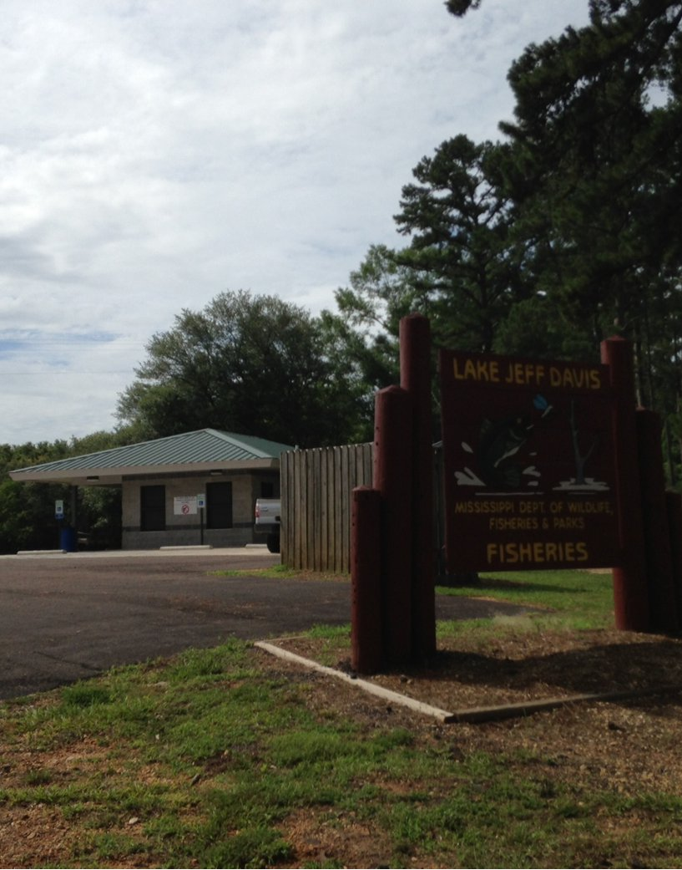

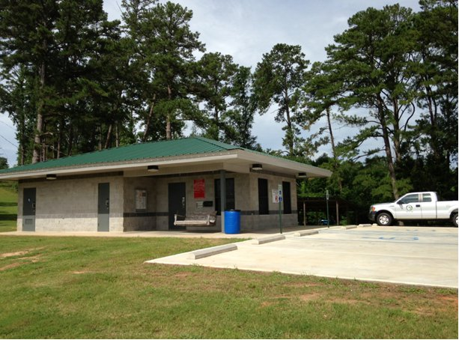
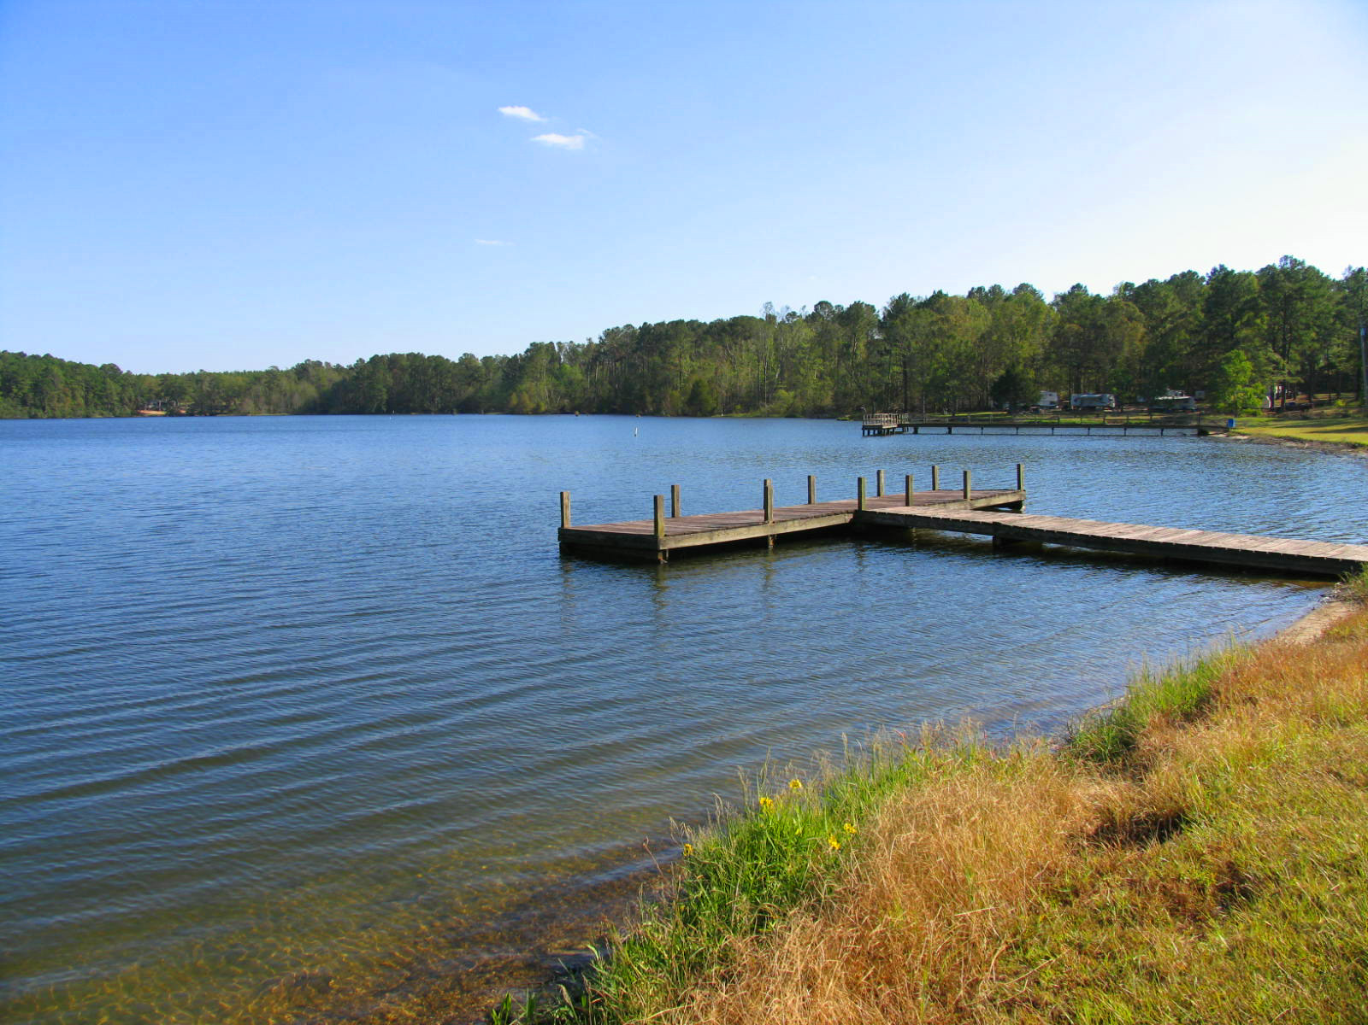
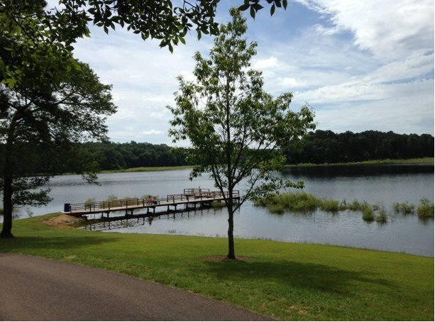
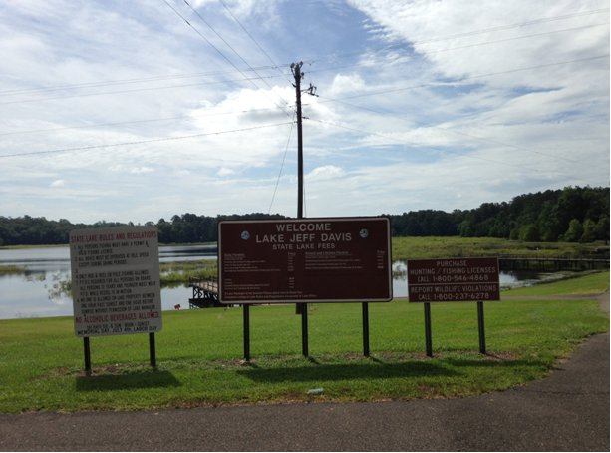
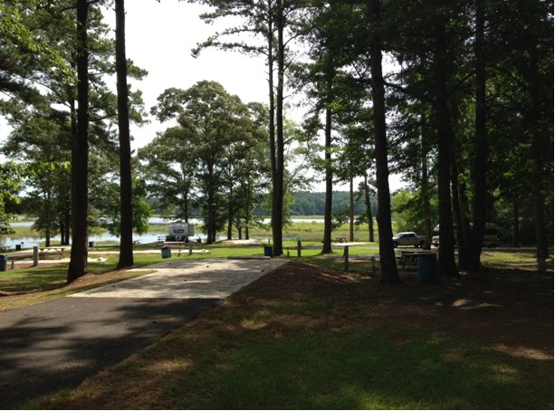
4-K Stables is a full care boarding facility that is a “horse owner's paradise.” It is a resort for horse owners and a welcome resting area for those who ride on the Equestrian Trail of the Longleaf Trace.
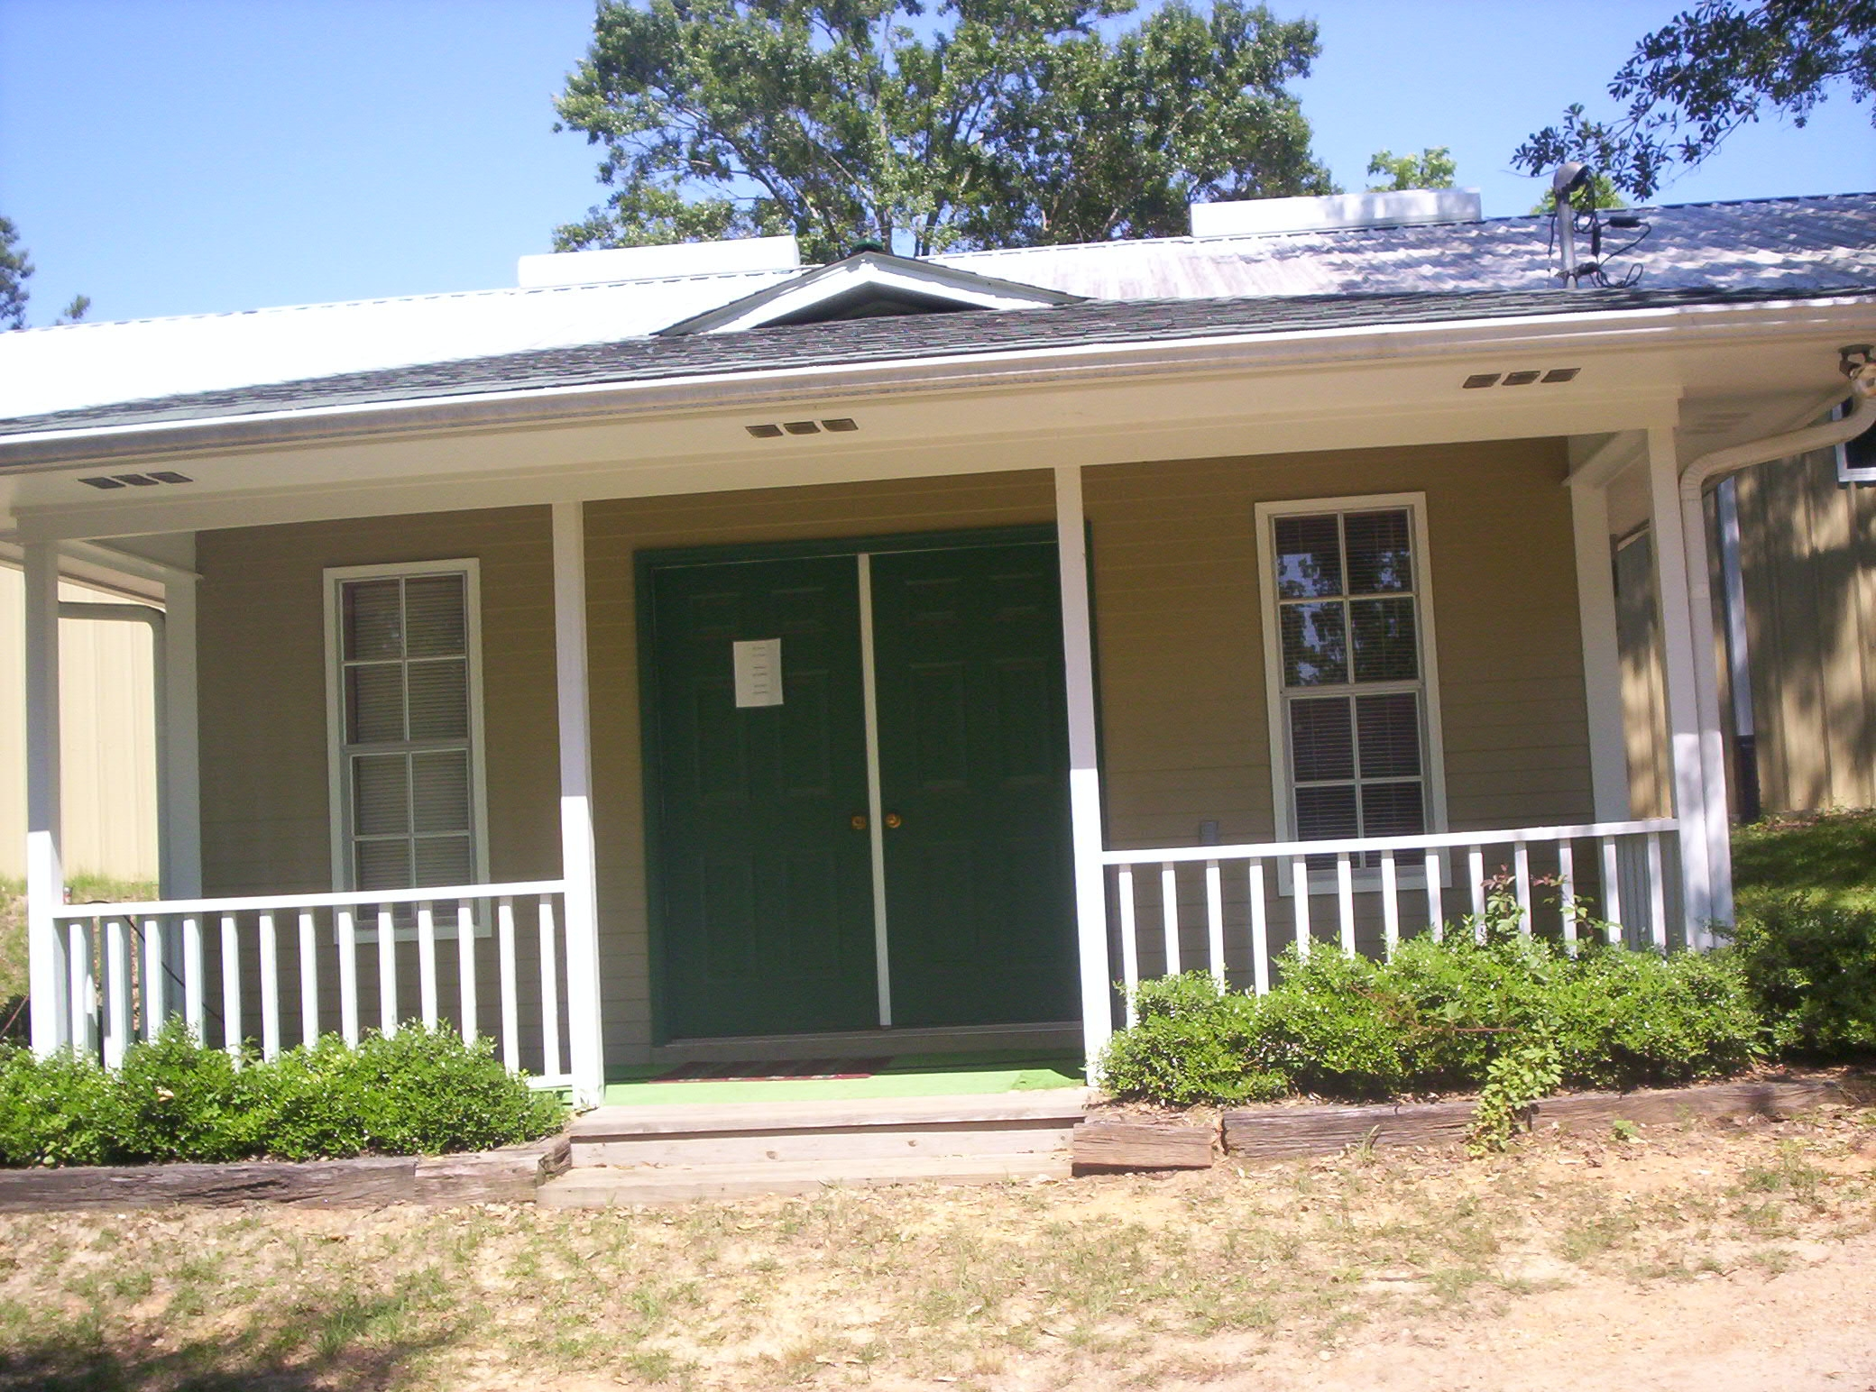
4-K is the closest campsite to the Longleaf Trace available. It consists of 10 indoor stables (with a wash rack for the horses), R.V. hook-ups, horse trailer grounds, a round pen and a bunk house. People can bring their campers, stable their horses and enjoy their time riding the trail. The bunkhouse is offered for those without an R.V. It is fully air-conditioned, offers cable T.V., and contains 2 single beds and one double bed. The stables are a great place for people who wish to vacation with their animals and enjoy the beautiful scenery of the trail. It is also perfect for anyone who might be traveling through with horses and need a rest.
Johnny Kerley is the owner and comes from a long line of horse lovers. His grandfather, Will Kerley, used to travel to Fort Worth, Texas to buy horses and mules and bring them to Jefferson Davis County to sell to farmers. Johnny said the older generation used to welcome his grandfather's return and would parade all of the livestock down the main street of Bassfield. Kerley's father, Jack, also raised horses.
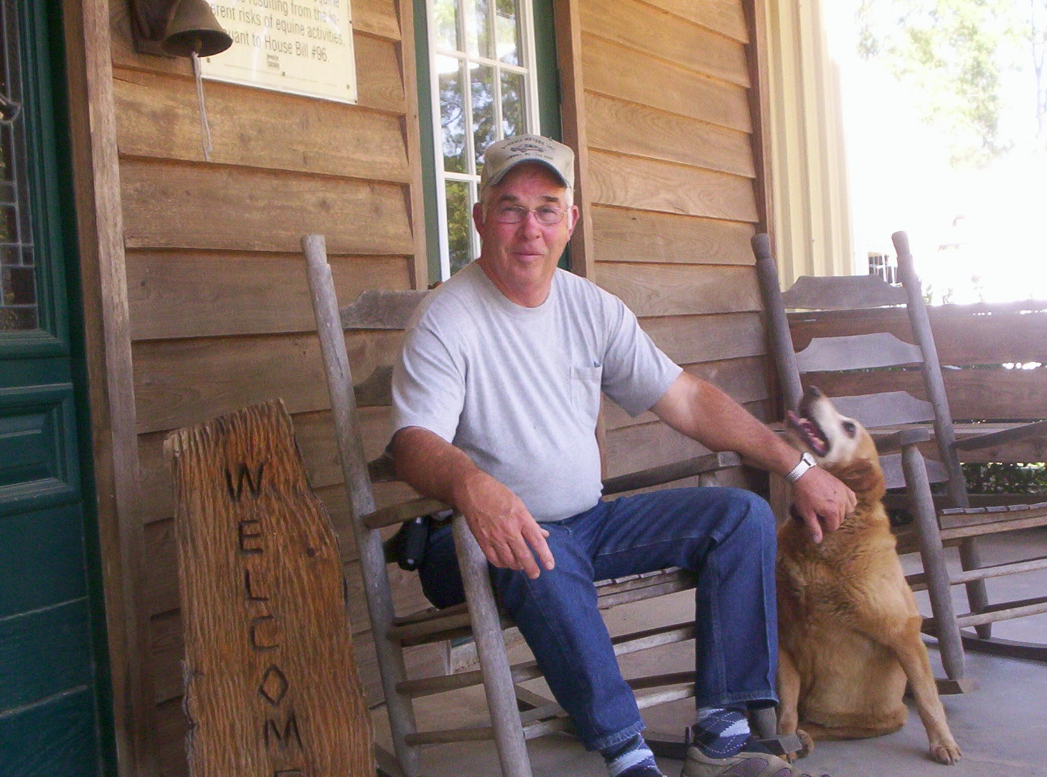
Johnny has owned horses all of his life and his youngest son, Jason, has taken up the tradition that has now spanned four generations. For more information on 4-K Stables, contact Johnny Kerley at (601) 943-5003 or (601) 408-8804.

